Organization event page:
1. IITER: https://iiter.org/conf/index.php?id=2455143&source=aca
2. Research foundation: https://researchfoundation.net/event/index.php?id=2454974&source=aca
3. WRF: https://www.wrfconference.com/event/index.php?id=2449547&source=aca
4. SNET: https://sciencenet.co/event/index.php?id=2477806&source=aca
5.Research leagues: https://researchleagues.com/event/index.php?id=2448568&source=aca
6. IIERD: https://www.iierd.org/events/index.php?id=2439921&source=aca
7. Research society: https://researchsociety.co/event/index.php?id=2292909&source=aca
8. Science leagues: https://scienceleagues.com/events/index.php?id=2452104&source=aca
9. World academics: https://worldacademics.net/event/index.php?id=2453688&source=aca
10. Research plus: https://researchplus.co/event/index.php?id=2456398&source=aca
11. ISER: https://iser.org.in/conf/index.php?id=2452982&source=aca
12. ASAR: https://asar.net.in/event/index.php?id=2441194&source=aca
13. Science Cite: https://www.sciencecite.com/event/index.php?id=2443883&source=aca
14. Research fora: https://www.researchfora.net/event/index.php?id=2447596&source=aca
15. IIRST: https://www.iirst.com/event/index.php?id=2293942&source=aca
16. ITAR: https://itar.in/conf/index.php?id=2294853&source=aca
17. AFTER: https://after.org.in/event/index.php?id=2444880&source=aca
18. SAIRAP: https://sairap.org/conf/index.php?id=2446803&source=aca

For IITER
Male dummy photo
Aissa Boudjella
Samarqand International University technology, Uzbekistan

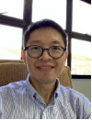
Sunny Goh Eng Giap
Universiti Malaysia Terengganu, Malaysia

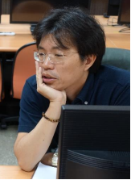
Avus Hou
Asia Eastern University of Science and technology, Taiwan

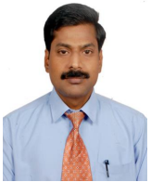
Dr. KOTTEESWARAN RANGASAMY
St.Joseph's College of Engineering, India
***********************************************************************************************************************
For ITAR
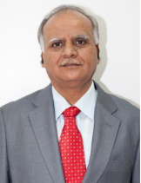
Jagannatha Rao Kosagisharaf
KL Deemed to be University, India
************************************************************************************************************************
For Research foundation
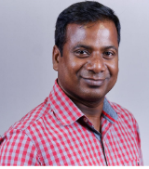
Suban Sahoo
Sardar Vallabhbhai National Institute of Technology, India

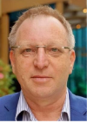
Yuval Yaron
Tel Aviv Sourasky Medical Center, Tel Aviv University, Israel

Dr. KOTTEESWARAN RANGASAMY
St.Joseph's College of Engineering, India

Eduard Albay
Don Mariano Marcos Memorial State University, Philippines
************************************************************************************************************************
For WRF
Male dummy photo
Aissa Boudjella
samarqand international university technology, Uzbekistan

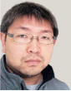
Hsien-Ming Lee
Academia Sinica, Taiwan, Province of China

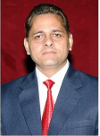
Dr.Subhash Chander Dubey
Govt.College of Engineering and Technology,Jammu-INDIA, India

Female dummy photo
Asso. Baysah
Adventist University of West Africa, Liberia
************************************************************************************************************************
For Sciencenet

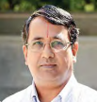
Narasimhan M S
Indian Institute of Management Bangalore, India
************************************************************************************************************************
For Research leagues

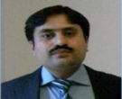
Dr. Muhammad Umer
COMSATS University Islamabad, Pakistan

Male dummy photo
Dipak Sahoo
Woxsen University, India
************************************************************************************************************************

For IIERD

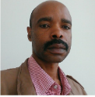
Clement Langa
Eswatini Medical Christian University, Swaziland

Male dummy photo
Govind Sharan Dangayach
Malaviya National Institute of Technology Jaipur, India
************************************************************************************************************************
For Research society

Female dummy photo
Bahar Muhammed
Salahaddin University- Erbil, Iraq

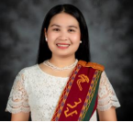
ARCHIE LAUDERES
NORTHWEST SAMAR STATE UNIVERSITY, Philippines

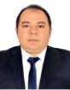
Deyaa eldin Mohamed Sabra
National Research Centre, Egypt

Male dummy photo
Abdolamir Allameh
Faculty of Medical Sciences, Tarbiat Modares University, Iran, Islamic Republic of
************************************************************************************************************************

For Science leagues

Male dummy photo
Sampath Talluri
Western Michigan University, United States

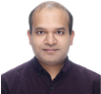
ASHUTOSH SHARMA
AMITY UNIVERSITY JHARKHAND, RANCHI, INDIA, India

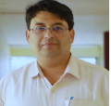
Amit Gautam
Banaras Hindu University, India

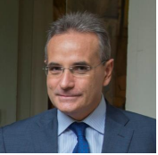
Marcello Martinez
UniversitÃ della Campania, Italy
************************************************************************************************************************
For World academics

Male dummy photo
Khalaf S Gaeid
Tikrit University, Iraq

Female dummy photo
JAYASHREE SUBRAMANIAN
PSG COLLEGE OF TECHNOLOGY, India

Male dummy photo
Kasim Alomari
University of ThiQar, Iraq

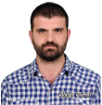
Ali Ulvi Ozbey
Bitlis Eren University, Turkey

Male dummy photo
Diogo Jacintho Barbosa
Estacio de SÃ¡ University (Rio de Janeiro - BRAZIL) and SÃ£o Carlos Federal University (SÃ£o Paulo - BRAZIL), Brazil

Dr. KOTTEESWARAN RANGASAMY
St.Joseph's College of Engineering, India

Alesa Durgaryan
ASPU, Armenia

Female dummy photo
Hena Yasmin
sifundzani, Swaziland

Female dummy photo
Anita Dani
University of Fraser Valley, Canada
************************************************************************************************************************
For Research plus

Male dummy photo
Yousif Ali Yousif Algabri
Shandong University, China

Dr. KOTTEESWARAN RANGASAMY
St.Joseph's College of Engineering, India

Josune RodrÃ­guez-Negro
University of the Basque Country (UPV/EHU), Spain
************************************************************************************************************************
For ISER

Male dummy photo
Aissa Boudjella
samarqand international university technology, Uzbekistan

Female dummy photo
Nizara Hazarika
Sonapur College, Sonapur, India

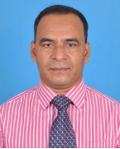
Dr Md Enamul Islam
Chattogram Cantonment College, Bangladesh
************************************************************************************************************************

For ASAR

Female dummy photo
Wee Sim Choo
Monash University Malaysia, Malaysia
************************************************************************************************************************

For Science Cite

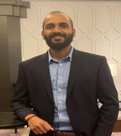
Sreehari Sreekumar
Ulster University, United Kingdom

Male dummy photo
Aissa Boudjella
samarqand international university technology, Uzbekistan

Female dummy photo
BINGQING Wu
University of Wisconsin, Parkside, United States

Dr. KOTTEESWARAN RANGASAMY
St.Joseph's College of Engineering, India
************************************************************************************************************************
For Research fora

Male dummy photo
Aissa Boudjella
samarqand international university technology, Uzbekistan

Josune RodrÃ­guez-Negro
University of the Basque Country (UPV/EHU), Spain
************************************************************************************************************************
For IIRST

Male dummy photo
Aissa Boudjella
samarqand international university technology, Uzbekistan
************************************************************************************************************************
For AFTER
Male dummy photo
Adewale, Olukayode Ogunrinade
Gombe State University, Nigeria
************************************************************************************************************************
For Science society
Male dummy photo
NILADRI MAITI
SCHOOL OF DENTISTRY- CENTRAL ASIAN UNIVERSITY, Uzbekistan

Josune RodrÃ­guez-Negro
University of the Basque Country (UPV/EHU), Spain
************************************************************************************************************************For SAIRAP
Dr. KOTTEESWARAN RANGASAMY
St.Joseph's College of Engineering, India
***************************************************************************************************************

