Mapping the Credibility of English Language Learning (ELL) Websites Based on Their Relevance and Level of Importance

[1]

**Nur Anisa Ibrahim Gani**1**, Hadina Habil**2

1 School of Education, Universiti Teknologi Malaysia, Johor Bahru, Malaysia.

2 Language Academy, Universiti Teknologi Malaysia, Johor Bahru, Malaysia.

**Email:** 1nuranisa@graduate.utm.my, 2hadina@utm.my

**Orchid Id number:** 10009-0001-9906-5183, 20000-0002-7509-5425

**Corresponding Author*:** Nur Anisa Ibrahim Gani.

**ABSTRACT:**

*In contemporary language teaching and learning, the World Wide Web plays a critical role, particularly by providing access to digital learning resources such as English Language Learning (ELL) websites. However, the expanding pool of ELL websites on search engines does not ensure the credibility of those resources for learning. Thus, this study attempts to map the credibility of 59 carefully selected ELL websites based on their relevance and level of importance. The research methodology employed two evaluation approaches, namely informal and automated. The first approach (informal) involved the evaluation conducted by four Excellent Teachers (ET) in relation to target audience, focus, setting possibilities, content, accessibility, and cost. The second approach involved using Website Grader (an automated evaluation tool) to analyse the websites' accessibility, specifically in terms of page size, requests, and speed. The results of this study revealed a positive correlation between websites' credibility in meeting the needs of diverse learners and their PageRank (PR). Group 2 websites (PR7-8) target a significantly larger audience and are more focused on broad activity. Simultaneously, these websites have a higher level of credibility because they can be accessed via both computers and mobile phones. Importantly, they are suitable for independent study. In essence, ELL websites have a lot to offer users. Thus, this study proposes a comprehensive list of crucial features of a credible ELL website, which will serve as a guide for the Ministry of Education and website hosts.*

KEYWORDS:

Computer-Assisted Language Learning, English Language Learning websites, website evaluation, credibility, PageRank.

1. **Introduction**

In contemporary language teaching and learning, the World Wide Web plays a critical role particularly by providing access to digital learning resources such as websites. Fundamentally, the growing number of English Language Learning (ELL) websites and their users [1] indicate that the convenience of accessing online information surpasses the act of going through books in terms of fulfilling individuals' language learning objectives. ELL websites provide an extensive array of authentic resources for learning a language [2]-[3]. Furthermore, the diverse range of content offered on these platforms accommodates various learning styles, enhancing the learning experience by making it more interesting and captivating [1]-[4].

In recognition of the unlimited possibilities offered by these tools, many teachers choose to employ ELL websites to deliver dynamic, engaging learning experiences, only to encounter credibility issues [5]. In reality, [5]’s study revealed a few key shortcomings, including a lack of culturally relevant content, insufficient writing tasks, and certain accessibility issues in remote areas. [6] highlighted another concern regarding the credibility of the ELL website in their study, focusing on learners in the Polish context. the content of the evaluated website was found as consisting mistakes. Besides, the exercises were found as highly translated which impact the overall language learning process. Indeed, websites continue to suffer from a variety of usability issues, including difficult-to-understand content, inconsistent formats, poor navigation capabilities, and disorientation [7]. According to [7], these factors may have a detrimental impact on website credibility.

Interestingly, the expanding pool of free websites on search engines does not ensure the credibility of those resources for learning [1]-[8]. Thus, assessing the credibility of websites is essential in order to choose high-quality and reliable online resources [9]. Website evaluation is critical in determining the website's effectiveness, credibility, and user satisfaction [10]. This process is particularly important in addressing the limitations and further accentuating the credibility of these influential resources among both educators and learners.

The drive to study the credibility of ELL websites is motivated by the concern that digital educational resources are more accessible nowadays, coupled with the trend of online learning. Apart from that, emphasizing website credibility will ultimately result in higher user engagement [7], as it plays a crucial role in determining a website's favourability [11]. This will definitely be beneficial for the website hosts.

Surprisingly, despite the extensive research on evaluating ELL websites' affordances for second language development, there is a notable lack of comprehensive credibility evaluations that categorise these resources based on crucial categories. Despite the extensive research on website evaluation, there remains a notable deficiency in comprehensively mapping the credibility of these resources [5]. To date, no studies on the internet have specifically focused on studying the credibility of a corpus of ELL websites (selected according to their level of importance) within the Malaysian context.

Therefore, this study aims to answer the following two questions:

1. How credible are the frequently visited ELL websites in relation to target audience, focus, setting

possibilities, content, accessibility, and cost?

1. What are the most prevalent features of frequently visited ELL websites according to their level of importance and relevance?

Analysing the evaluations executed by teachers in mapping the credibility of ELL websites would provide valuable key points to website providers, enable them to effectively address learners' concerns, and potentially improve the overall quality of the resources. This information will help the Ministry of Education (MoE), specifically the curriculum development division, better understand the significant features of credible ELL websites and the important characteristics of reliable ELL websites. This knowledge will be valuable for creating ELL websites for Malaysian learners. While this study involving ELL website evaluation is currently receiving little attention, it has the potential to provide valuable perspectives to researchers and practitioners in the same field.

1. **Literature Review**
   1. **Multiple Evaluation Categories to Determine Websites Credibility**

Indeed, Credibility encompasses various definitions, primarily two crucial elements which are trustworthiness and knowledge [12]. Credibility can be analysed in terms of trustworthiness and expertise [13]. Trustworthiness refers to the level of confidence and acceptance that listeners have in the message of the speakers. Expertise refers to the quality of sources being authentic, authoritative, and legitimate from the perspective of the audience [13].

Some studies use multiple categories to describe credibility, allowing for a more comprehensive understanding [14]. For instance, the study conducted by [15], which involved a total of 1519 English academics from 139 universities in China, focused on various aspects such as language areas and skills, materials, language users’ preferences, and usability to determine the credibility of ELL websites and digital resources.

According to [16] language learning websites should follow theoretically-informed fundamentals for second language development. Particularly, these websites attempt to facilitate self-learning by providing learning aids and materials [16]. Thus, they listed the baseline evaluative criteria for a credible website, as content, objectivity, currency, navigation, and authority with additional attention to learners’ attitudes, motivation, interactions, and instructional objectives.

Another study by [17] with the aim of designing a list of comprehensive criteria to assist educators assess the quality of ELL websites view the existence of appropriate resources to support language skills as the main determinant of ELL websites’ credibility. Fifty-eight evaluation criteria designed were based on usability, resources, functionality, technology integration, and preferences.

The multiple evaluation categories are sometimes arranged in systematic frameworks for credibility evaluation. These frameworks are commonly used to guide the overall assessment procedure. For instance, [18] conducted a study to evaluate Duolingo, an online language-learning platform providing courses in 27 different world languages. [18] assessed the website's credibility using [19]’s framework, which comprises six evaluation categories. The categories are technical preview, operational description, teacher fit, learner fit, implementation schemes, and appropriateness judgments.

A few studies, such as [1] and [20], offer rather simplified evaluation categories. [1] evaluated the credibility of ELL websites based on two main categories: functionality and usability, via a carefully crafted checklist. A comparative study of four selected ELL websites validated the evaluation categories.

Comparatively, [20] conducted a study where the sole evaluation category of a language learning website is usability. The study aimed to provide educators and course designers with an extensive knowledge of elements that influence the usability and design of a language learning website. The findings of this study help them make informed decisions about future website design and development.

In essence, these evaluation categories are determined by the objectives, frameworks or guidelines used in a particular study [19]. Since this study aims at evaluating and mapping the credibility of a huge sample size, a simple but comprehensive evaluation criteria list which comprises both technical and pedagogical concerns was selected and applied.

* 1. **Credibility of ELL Websites**

Several research studies such as [5], [20], [21], [22] and [23] have examined the credibility of websites in the field of language learning. The studies conducted by [20] and [21] revealed the credibility of ELL websites in providing resources to support the development of language skills such as reading, writing, listening, and speaking.

[21] conducted a study with 143 learners and found that ELL websites are beneficial for enhancing learners' language skills. According to them, the participants reported that ELL websites offered authentic educational resources that helped them improve their vocabulary. Similarly, [20] findings proved the credibility of ELL websites in terms of the availability of various resources to support the development of language skills. The majority of respondents expressed positive reactions to the language learning websites they used.

Regarding the credibility of supporting independent and autonomous learning, [5] conducted an evaluation of a carefully selected ELL website, highlighting the resource's potential as a platform for self-learning. The provision of an abundance of resources arranged according to different levels assists the learners to organise and learn at their own convenient time. Furthermore, in his study, [23] discusses the capacity of ELL websites to support autonomous learning among learners. Some of the websites that cost payment offer users the opportunity to have live chats with native English speakers at any time [23]. This opportunity will lead to the development of more self-directed learners who can independently navigate their own learning process with the assistance of virtual, knowledgeable others.

Finally, in relation to providing supplementary materials to support language learning, [22] states that ELL websites serve as supplementary materials or resources that offer assistance in language acquisition. This is supported by the results of his study with undergraduate students from Uva Wellassa University. The participants were assigned tasks related to the websites in order to ensure they had adequate familiarity with them. Overall, the findings indicated positive attitudes toward the capacity of ELL websites as supplemental tools for acquiring English language skills. The findings also indicated that a significant proportion of students (88%) perceived ELL websites as efficacious and captivating tools for enhancing their learning [22]. Given the time and resource constraints in schools, websites hold significant potential as a beneficial supplement or replacement for classroom instruction.

However, while numerous studies have focused on assessing the credibility of a limited websites sample, there has been relatively little research on the evaluation of a corpus of ELL websites specifically within the Malaysian context. Therefore, it is imperative to address the significant need for filling the gap that motivates this study. The next section provides a comprehensive explanation of the overall methodology employed in this research.

**3) Methodology**

This quantitative study consists of two consecutive stages with different procedures. There are two stages: selection and evaluation.

*Selection Stage*

The selection stage aimed at determining the research sample. The pool creation process yielded 65 ELL websites, included in the list due to their appearance on the first and second pages of the Meta search engine. Since this study aims at mapping the credibility of ELL websites based on their relevance and level of importance, a Google PageRank (PR) tool was used to select ELL websites with PR 4 and above. According to [24], PageRank is a reliable tool that assist in determining the level of importance of websites within the search engine. PageRank uses ten levels to rank websites, as described in Table 1 below. Higher levels indicate greater importance and relevance.

**Table 1**

Three-level scale for ratıng the relevance and level of importance of websites

|  |  |  |
| --- | --- | --- |
| **PageRank (PR)** | **Level of Importance** | **Relevance** |
| 0-3 | Slightly Important | Low |
| 4-6 | Important | Moderate |
| 7-10 | Very Important | High |

Table. 1 shows the three-level scale for ratıng the relevance and level of importance of websites.

*Evaluation Stage*

The evaluation stage seeks to map the credibility of ELL websites based on the evaluation categories. The evaluation procedure was initiated with a surface check where the link of each website was visited to verify its domain availability and confirm its ELL status. Four of the links were omitted due to the unavailability of the domain; seven links were not ELL websites, and one link showed the same domain as the previous link in the selection list.

Thus, only 53 ELL websites passed the checking procedure and were selected as the sample for this study.

**Table 2**

Number of ELL websites according to PR

|  |  |
| --- | --- |
| PageRank (PR) | Number of Websites |
| 4 | 7 |
| 5 | 21 |
| 6 | 12 |
| 7 | 7 |
| 8 | 6 |

Table. 2 shows the 53 ELL websites based on their PR.

The evaluation is conducted based on six evaluation categories outlined from six guiding questions proposed by [25]. There are six categories and nine sub-categories. The evaluation categories are as follows:

**Table 3**

The evaluation categories

|  |  |
| --- | --- |
| Categories | Sub-categories |
| Target Audience | 1. Beginners/ elementary 2. Intermediate 3. Advanced 4. English for Specific Purposes |
| Focus | Overall Focus   1. Pedagogy 2. Content 3. Examination   Activity Focus   1. Vocabulary 2. Macro-skill 3. Grammar   Macro-skill   1. Listening 2. Speaking 3. Reading 4. Writing |
| Setting Possibilities | 1. Teacher-Led with a Computer 2. Teacher-Led with few Computers 3. Independent Study |
| Content | Relationships with Malaysian Curriculum  1. Supplementary  2. Complementary  3. Central  Cultural Relevance  1. Western- oriented  2. Eastern- oriented |
| Accessibility | 1. Computer  2. Mobile Phone  3. Page Size  4. Page Speed  5. Page Request |
| Cost | 1. Completely Free 2. Partially Free 3. Paid |

Table. 3 shows the evaluation categories which are arranged according to their sub-categories.

The 53 selected ELL websites were evaluated by four Excellent Teachers based on the aforementioned categories. Only three sub-categories related to accessibility (page speed, page request, and page size) were evaluated using an automated evaluation tool, Website Grader. As stated by [26], Website Grader is an appropriate tool to evaluate websites accessibility.

A particular website received one point for fulfilling each sub-category. The points were accumulated and presented in the form of percentages. The percentage of websites according to PR levels for each category were mapped on a radar chart. The nine charts highlight the points of similarity and difference between the respective website sets. The evaluation data gathered was analysed and discussed comprehensively.

**3] Results**

*The* *credibility of frequently visited ELL websites in relation to target audience, focus, setting possibilities, content, accessibility, and cost*

The first part of the analysis focuses on visualising the credibility of the selected sample according to the evaluation categories.

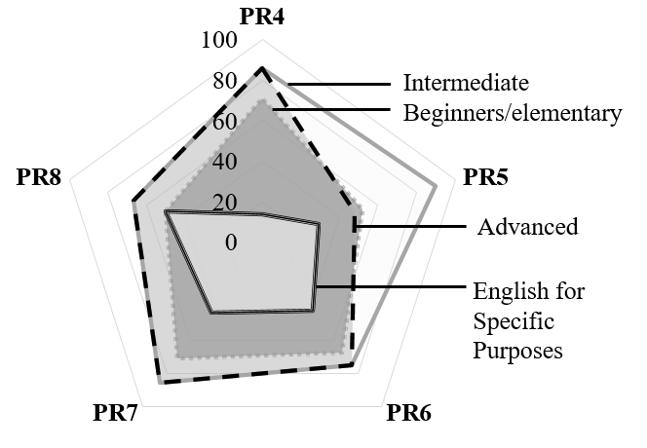

**Figure** **3(a)** The credibility of frequently visited ELL websites in relation to target audience

Figure 3(a) shows the credibility of 53 frequently visited ELL websites in relation to their target audience. The majority of the ELL websites with PR4–8 are appropriate for intermediate learners. Advanced learners are the next most common target audience across all website levels, closely followed by beginners or elementary learners. Interestingly, English for Specific Purposes is the least covered audience on all levels of websites, except for those with PR8. Overall, PR8 websites target a significantly broader audience than PR7, PR6, PR5, and PR4 websites, respectively.

The analysis of the second category, focus, comprises three sub-categories: overall focus, activity focus, and macro-skill focus.

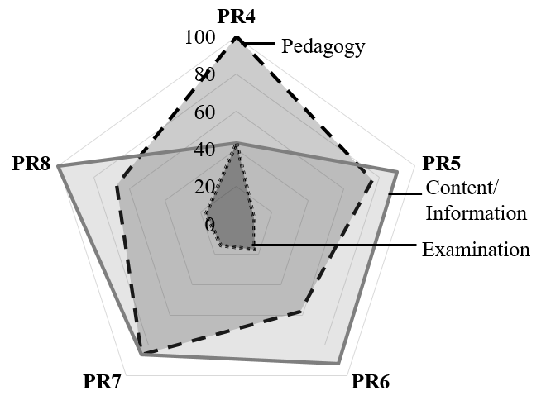

**Figure 3(b)** The credibility of frequently visited ELL websites in relation to overall focus

Figure 3(b) shows the credibility of 53 frequently visited ELL websites in relation to their overall focus. Analysis revealed that most of the websites, irrespective of their PR, concentrate on multiple categories. Websites with PR4 focus on pedagogy, followed by the same percentage of coverage for both content and examination. The most notable comparison is that PR4 websites are completely pedagogy-oriented, whereas PR8 websites are completely content- or information-oriented. While the majority of PR5 and PR6 websites were content- or information-oriented, the majority of PR7 websites demonstrated dual orientations (pedagogy and content), with the same percentage achieved for both. Comparatively, a limited number of websites from all PRs are reported as examination-oriented.

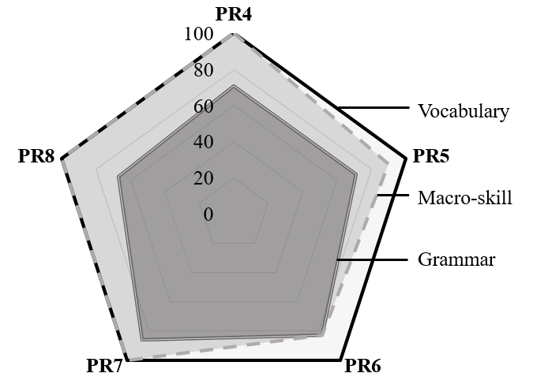

**Figure** **3(c)** The credibility of frequently **visited ELL websites in relation to activity focus**

Figure 3(c) shows the credibility of frequently visited ELL websites in relation to activity focus. All PR4, 5, 6, 7, and 8 websites provide activities directed at learning vocabulary. All websites with PR4, 7, and 8 offer activities that support the development of macro-skills (reading, writing, listening, and speaking). However, the limited number of PR5 and 6 websites lack these activities. An extensive suite of grammar activities is available on most of the websites, regardless of their PR.

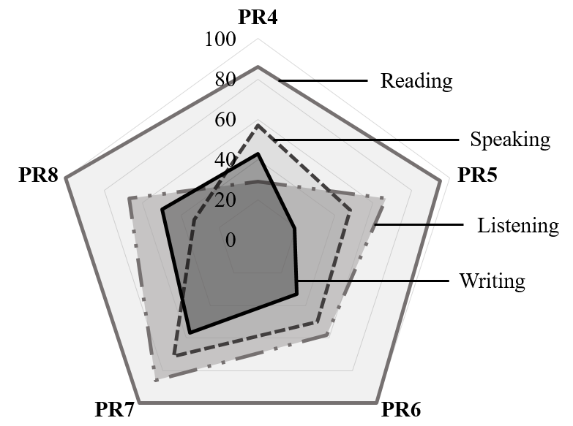

**Figure** **3(d)** The credibility of frequently visited ELL websites in relation to macro-skill focus

Figure 3(d) shows the credibility of frequently visited ELL websites in relation to macro-skill focus. It is evident that all websites of PR6, 7, and 8 consist of a wide range of activities for teaching reading skills. Moreover, the majority of PR4 websites and nearly all PR5 websites feature reading activities. The second most focused skill on PR5 and above websites is listening skill. There are a variety of audio and video resources available on these websites. In other words, the only level with very few listening resources is PR4. All websites, with the exception of those in PR8, place the least emphasis on writing skills. On PR8 websites, the limited availability of resources for speaking skills is evident.

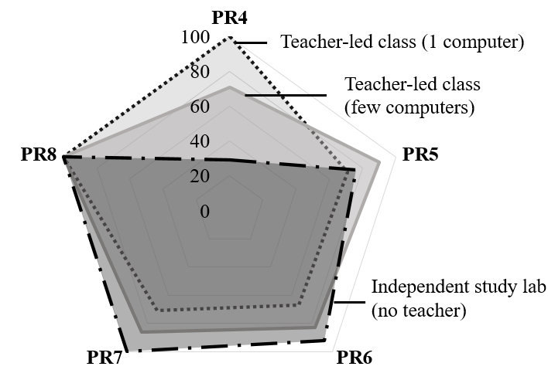

**Figure** **3(e)** The credibility of frequently visited ELL websites in relation to setting possibilities

Figure 3(e) shows the credibility of frequently visited ELL websites in relation to setting possibilities. All PR8 websites can be used in all settings. All PR7 websites can be used for independent learning, and the majority of PR6 websites are usable for independent learning. Significantly, all PR4 websites can be used in a teacher-led classroom with one computer. Contrastingly, almost all PR5 websites can be used in teacher-led classes with few computers. However, it is crucial to emphasise that only a few websites with PR4 are suitable for independent learning.

The next category, content, comprises two sub-categories, which are relationships with curriculum and cultural relevance.

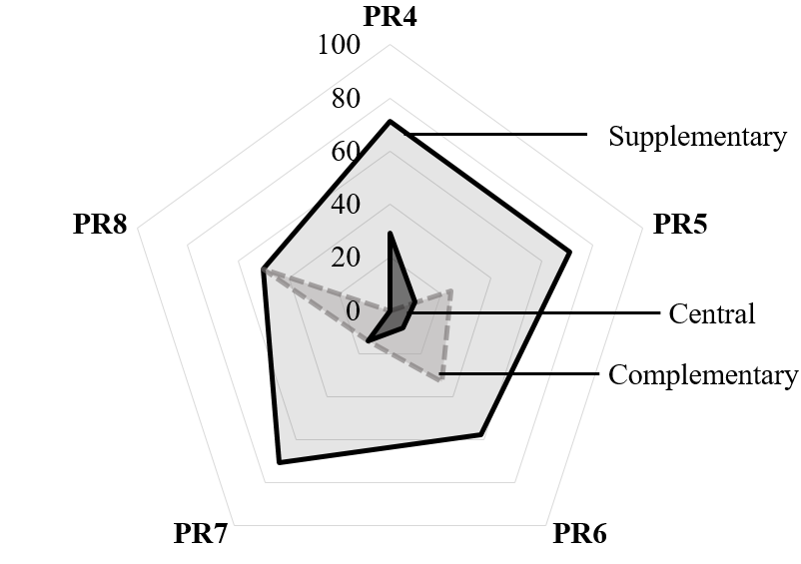

**Figure** **3(f)** The credibility of frequently visited ELL websites with regards to relationships of the content with the Malaysian curriculum

Figure 3(f) shows the credibility of frequently visited ELL websites with regard to the relationship between the content and the Malaysian curriculum. The majority of websites with PR4 to PR7 were found to have a supplementary relationship with the Malaysian curriculum. The distribution of PR8 websites evenly fell into two categories: supplementary and complementary relationships with the Malaysian curriculum. Importantly, none of the PR8 websites were reported as having central relationships, and none of the PR4 websites were reported as having complementary relationships. Despite being the least prevalent category among PR5, 6, and 7, a significant number of PR4 websites demonstrated central relationships with the Malaysian curriculum.

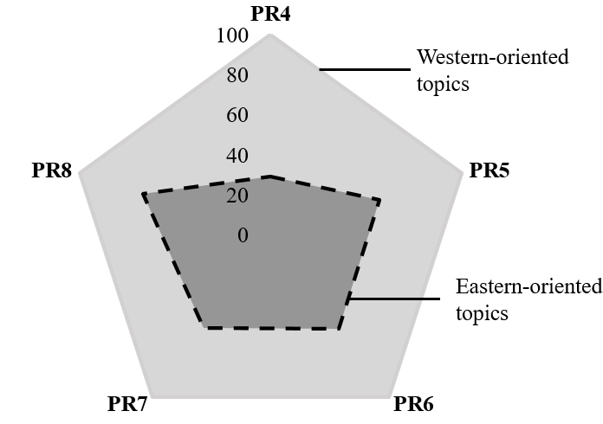

**Figure 3(g)** The credibility of frequently visited ELL websites in relation to cultural relevance of the content

Figure 3(g) shows the credibility of frequently visited ELL websites in relation to the cultural relevance of the content. All websites, across all PR levels, contain Western-oriented topics. A moderate number of websites across PR5 and above, followed by fewer than half of PR4 websites, feature Eastern-oriented topics.

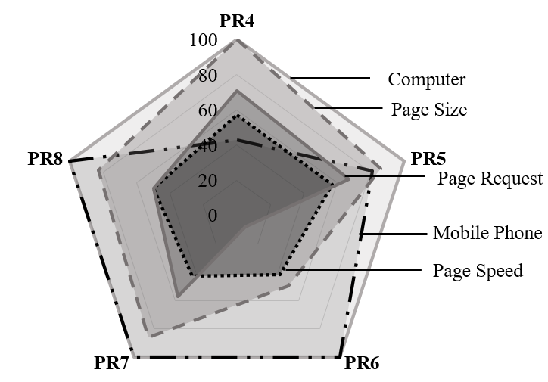

**Figure 3(h)** The credibility of frequently visited ELL websites in relation to accessibility

Figure 3(h) shows the credibility of frequently visited ELL websites in relation to accessibility. All PR4-8 websites can be accessed via computer with no major issues. All PR6-8 websites are accessible via mobile phone. A significant proportion of PR5 websites and a small number of PR4 websites are accessible via mobile phone. Surprisingly, in terms of the remaining technical accessibility features evaluated using Website Grader, all PR4 websites fulfil the requirement of efficient page size, followed by the majority of PR8, PR7, PR5, and PR6 websites. A moderate proportion of websites of all PR levels satisfy the requirement for efficient page speed. This trend is evident in the number of page requests, and it is particularly noteworthy for PR6 websites, as none of them meet the requirements for this category.

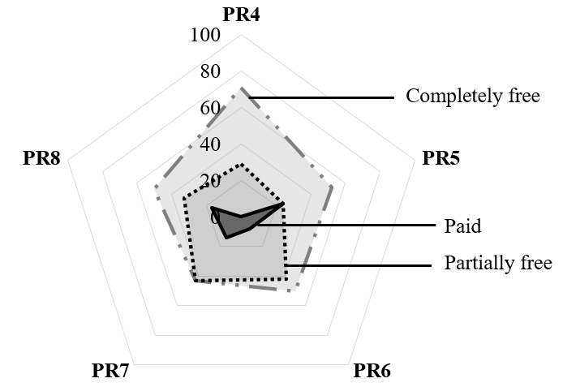

**Figure 3(i)** The credibility of frequently visited ELL websites in relation to cost

Figure 3(i) shows the credibility of frequently visited ELL websites in relation to cost. The majority of all PR-level websites were completely free for users, while a moderate proportion of websites required payment for certain resources. Additionally, the same percentage was applied to paid PR5 websites. Surprisingly, none of the PR4 websites require subscription fees, followed by a limited number of websites with PR6, 7, and 8 that are in the paid category.

*The* *most prevalent features of frequently visited ELL websites according to their level of importance and relevance.*

The second part of this study provides a list of the most common features of frequently visited ELL websites, according to PR groups.

**Table 4**

The most prevalent features of frequently visited ELL websites according to their level of importance and relevance

|  |  |  |
| --- | --- | --- |
| Categories | According to PR Groups | |
| Group 1  PR 4-6  (Important &  Moderately Relevant) | Group 2  PR 7-8  (Very Important & Highly Relevant) |
| Category 1: Target Audience | | |
| Target Audience | Intermediate | Intermediate  & Advanced |
| Category 2: Focus | | |
| Overall Focus | Pedagogy | Pedagogy |
| Activity Focus | Vocabulary | Vocabulary & Macro-skill |
| Macro-skill Focus | Reading | Reading |
| Category 3: Setting Possibilities | | |
| Setting Possibilities | NONE | Independent Study |
| Category 4: Content | | |
| Relationships with Curriculum | Supplementary | Supplementary |
| Cultural Relevance | Western- oriented | Western- oriented |
| Category 5: Accessibility | | |
| Accessibility | Computer | Computer & Mobile Phone |
| Category 6: Cost | | |
| Cost | Completely Free | Completely Free |

Table 4 shows the most prevalent features of frequently visited ELL websites, according to their level of importance and relevance. These websites were divided into two groups, which are Group 1 (PR 4-6: Important and Moderately Relevant) and Group 2 (PR 7-8: Very Important and Highly Relevant). Surprisingly, both groups of websites were found to show the same credibility in terms of five sub-categories. Both groups are driven by pedagogy as the overall focus. The most focused macro-skill for both groups of websites is reading. The content is Western-oriented and has supplementary relationships with the curriculum. The majority of websites are completely free.

However, there are significant differences among Groups 1 and 2 for the remaining four sub-categories. Group 2's websites target a significantly broader audience (intermediate and advanced) than Group 1's (intermediate). Simultaneously, group 2 websites are more focused on broad activity (vocabulary and macro-skills) than group 1 websites (vocabulary). Furthermore, group 2 websites have a higher level of credibility than group 1 websites because they are accessible via both computers and mobile phones. Importantly, group 1 websites did not report any common setting possibilities, while group 2 websites are suitable for independent study.

**4] Discussion**

In relation to the target audience, all of the websites, regardless of their PR levels, cater to the needs of more than a group of learners, with intermediate-advanced being the most prevalent combination. However, it's important to note that only a small percentage of PR4 websites target ESP learners. Overall, the majority of PR8 websites have a significantly larger audience than PR7, PR6, PR5, and PR4 websites in their respective order. Thus, it is evident that there is a positive correlation between the credibility of websites in meeting the needs of diverse learners and their PR. This crucial finding contradicts the findings of the study conducted by [27], who examined a sample of 25 Chinese ELL websites with different PR levels ranging from PR4 to PR6. The findings demonstrate a clear negative link between a website's PR level and users’ language competence. This suggests that as the PR progresses, the users’ proficiency level plunges.

In terms of the overall focus, all of the frequently visited websites are directed towards at least two categories.

The combinations can be pedagogy and content-oriented, or pedagogy and examination-oriented. This highlights the broad overall focus of the frequently visited ELL websites.

In terms of activity focus, the activities offered on all of the frequently visited websites are either a combination of vocabulary and grammar-focused or vocabulary and skill-focused. In terms of macro-skills, none of the websites focus on a single language skill. The minimum number of skills offered by a particular frequently visited ELL website is two. Interestingly, vocabulary is the most common activity focus, reflecting the initial stage of language learning through words and the abundance of reading resources available on all ELL websites. Moreover, ELL websites primarily cover reading as a skill. In a similar vein, [21] in their study supported the role of ELL websites in improving learners’ language skills, specifically through vocabulary enhancement [21].

Websites with higher PR levels are more credible due to the notable disparity between those in PR4 and those in PR8, as all PR8 websites are suitable for all settings. The discovery further confirms that only a limited number of websites with a PageRank of 4 are suitable for independent learning. In essence, it is crucial to highlight that the majority of the sample evaluated supports autonomous learning. This is in line with [23], who supported the crucial role of language learning websites in the success of self-directed learning. Therefore, using ELL websites in a language learning setting will result in more self-directed learners who are capable of independently managing their own learning.

All ELL websites appear to have relationships with the Malaysian curriculum, be they supplementary, complementary, or central, with supplementary relationships being the most prominent sub-category in terms of content credibility. This reinforces the results of [22]’s study. The overall results indicated favorable attitudes toward the capacity of ELL websites as supplementary resources for learning English. Besides, [5] through their findings, strengthened the credibility of ELL websites as enrichment activities and supplementary tasks for Malaysian primary school students. Considering the limitations of time and resources in language teaching, it may be deduced that websites have considerable promise as a valuable alternative for classroom instruction. Primarily, the majority of ELL websites are available at no cost. The Ministry of Education should explore these resources since they provide interactive and updated learning materials without requiring additional funding for subscription fees.

Thus, this study proposes a comprehensive list of crucial features of a credible ELL website, which are as follows:

i. Diverse target audiences

ii. Broad overall focus

iii. Various activity focus

iv. Various language skills

v. Usable in all settings

vi. Availability of curriculum-related resources

vii. Culturally relevant

viii. Accessibility across devices

ix. Availability of free resources

**5] Conclusion**

This study concludes that ELL websites have much to offer to users. The aforementioned insights provide website hosts with helpful ideas about the limitations and pressing necessity of enhancing the credibility of their websites. This is crucial in order to guarantee the provision of good quality digital resources for all learners, irrespective of their individual characteristics as well as the time, location, and gadgets they use. The findings of this evaluation provide an understanding of the efficacy of automated evaluation tools for assessing language learning websites. As not all websites with high PR are great in relation to their technical quality, this study informs researchers of the vitality of investigating the relationships between PR and technical quality. Moreover, this initiative significantly contributes to the advancement of online learning in Malaysia by drawing attention to the potential of English Language Learning (ELL) websites as a means for teachers to offer authentic English language learning opportunities.

**6] Acknowledgement**

Special thanks to the Education Policy Planning and Research Division, Ministry of Education Malaysia for approving the research protocol.

**7] Funding Statement**

The authors did not receive financing for the development of this research.

**8] Data Availability**

The data that support the findings of this study are available from the corresponding author.  
 **9] Conflict of interest**

The authors declare that there is **no conflict of interest.**

**10] References**

[1] N. Aguayo and C. M. Ramírez, “Does technical assessment matter? Functionality and usability testing of websites for ESL/EFL autonomous learners,” *Res. Learn. Technol.*, vol. 28, pp. 1–26, 2020, doi: 10.25304/rlt.v28.2353.

[2] E. M. Fuentes and J. J. R. Martínez, “Design of a checklist for evaluating language learning websites,” *Porta Linguarum*, vol. 2018, no. 30, pp. 23–41, 2018.

[3] A. Alhabdan, “Evaluating English Learning Websites and Digital Resources From the Perspective of Saudi English Language Learners: Technical Assessment,” *Theory Pract. Lang. Stud.*, vol. 11, no. 6, pp. 639–651, Jun. 2021, doi: 10.17507/tpls.1106.07.

[4] S. Boulahnane and V. S. Abramova, “Exploring the Potential of online English Websites In Teaching English To Non-Linguistic Major Students: BreakingNewsEnglish As Example,” *Regist. J.*, vol. 12, no. 1, p. 1, Jun. 2019, doi: 10.18326/rgt.v12i1.1-12.

[5] N. A. I. Gani and H. Habil, “A Study on the Potential of an English Language Learning (ELL) Website,” *Proc. Int. Conf. Res. Lang. Educ. (I-RoLE 2023), 13-14 March, 2023, Noble Resort Hotel Melaka, Malaysia*, vol. 7, pp. 435–447, 2023, doi: 10.15405/epes.23097.39.

[6] A. Grygo and E. Gajek, “Risks of using duolingo by Polish learners at primary level,” *CEUR Workshop Proc.*, vol. 2390, no. October, pp. 21–24, 2019.

[7] Z. Huang and M. Benyoucef, “Usability and credibility of e-government websites,” *Gov. Inf. Q.*, vol. 31, no. 4, pp. 584–595, 2014, doi: 10.1016/j.giq.2014.07.002.

[8] N. A. Ibrahim Gani and H. Habil, “Evaluation of English Language Learning (ELL) Websites using Automated Evaluation Tool,” *Int. J. Acad. Res. Bus. Soc. Sci.*, vol. 13, no. 1, Jan. 2023, doi: 10.6007/ijarbss/v13-i1/16203.

[9] N. Yusof, “The credibility of Islamic religious institutional websites in Malaysia,” *J. Komun. Malaysian J. Commun.*, vol. 32, no. 2, pp. 82–104, 2016, doi: 10.17576/jkmjc-2016-3202-05.

[10] F. D. Saiful Bahry, M. Masrom, and M. N. Masrek, “Measuring validity and reliability of website credibility factors in influencing user engagement questionnaire,” *Int. J. Web Inf. Syst.*, vol. 17, no. 1, pp. 18–28, 2021, doi: 10.1108/IJWIS-08-2020-0050.

[11] E. Ageeva, T. C. Melewar, P. Foroudi, and C. Dennis, “Evaluating the factors of corporate website favorability: a case of UK and Russia,” *Qual. Mark. Res.*, vol. 22, no. 5, pp. 687–715, 2019, doi: 10.1108/QMR-09-2017-0122.

[12] B. Hilligoss and S. Y. Rieh, “Developing a unifying framework of credibility assessment: Construct, heuristics, and interaction in context,” *Inf. Process. Manag.*, vol. 44, no. 4, pp. 1467–1484, Jul. 2008, doi: 10.1016/j.ipm.2007.10.001.

[13] E. H. Jung, K. Walsh-Childers, and H. S. Kim, “Factors influencing the perceived credibility of diet-nutrition information web sites,” *Comput. Human Behav.*, vol. 58, pp. 37–47, 2016, doi: 10.1016/j.chb.2015.11.044.

[14] Z. Huang and M. Benyoucef, “Usability and credibility of e-government websites,” *Gov. Inf. Q.*, vol. 31, no. 4, pp. 584–595, 2014, doi: 10.1016/j.giq.2014.07.002.

[15] H. Shen, Y. Yuan, and R. Ewing, “English learning websites and digital resources from the perspective of Chinese university EFL practitioners,” *ReCALL*, vol. 27, no. 2, pp. 156–176, May 2015, doi: 10.1017/S0958344014000263.

[16] Y. T. C. Yang and C. Y. Chan, “Comprehensive evaluation criteria for English learning websites using expert validity surveys,” *Comput. Educ.*, vol. 51, no. 1, pp. 403–422, 2008, doi: 10.1016/j.compedu.2007.05.011.

[17] G. Z. Liu, Z. H. Liu, and G. J. Hwang, “Developing multi-dimensional evaluation criteria for English learning websites with university students and professors,” *Comput. Educ.*, vol. 56, no. 1, pp. 65–79, 2011, doi: 10.1016/j.compedu.2010.08.019.

[18] K. Teske, “Learning Technology Review -Duolingo,” *Calico J. Issn 2056–9017*, vol. 34, pp. 393–401, 2017.

[19] P. Hubbard, “Evaluating CALL Software,” *Call. CALL From Theory Res. to New Dir. Foreign Lang. Teach.*, no. c, pp. 313–338, 2006.

[20] Y. F. Chuah, F. L. Foo, and Z. M. Zaki, “Learners’ Evaluation of the Usability and Design Features of Chinese as a Foreign Language ELearning Websites,” *Int. J. Learn.*, vol. 2, no. 1, pp. 91–98, Jun. 2016, doi: 10.18178/IJLT.2.1.91-98.

[21] E. A. E. RahmtAllah and A. A.-S. Mohamedahmed, “EFL LEARNERS’ PERCEPTION OF USING ONLINE LANGUAGE LEARNING WEBSITES DURING COVID-19 PANDEMIC,” *Int. J. English Lang. Linguist. Res.*, vol. 9, no. 3, pp. 5–14, 2021.

[22] D. M. R. S. Dissanayake, “Perception of the Students on Obtaining the Assistance of ESL / EFL Websites to Learn English ; a Study with Special Reference to the Second Year Undergraduates of Uva Wellassa University,” in *International Research Symposium of UWU-2018*, Uva Wellassa University of Sri Lanka, 2018, p. 362. [Online]. Available: http://www.erepo.lib.uwu.ac.lk/handle/123456789/1681

[23] A. Oqilat, “Developing Evaluation Criteria for Advanced-level Students ’ Perspectives of English Language Learning Websites,” no. August, 2013.

[24] H. B. S. Reddy, R. R. S. Reddy, R. Jonnalagadda, P. Singh, and A. Gogineni, “Usability Evaluation of an Unpopular Restaurant Recommender Web Application Zomato,” *Asian J. Res. Comput. Sci.*, vol. 13, no. 4, pp. 12–33, 2022, doi: 10.9734/ajrcos/2022/v13i430319.

[25] N. Healey, D., & Johnson, “A place to start in selecting software,” *Comput. Assist. English Lang. Learn. J.*, vol. 8, no. 1, 1997, [Online]. Available: http://www.deborahhealey.com/cj_software_selection.html

[26] S. S. Khandare, S. Gawade, and V. Turkar, “Survey on website evaluation tools,” in *2017 International Conference on Recent Innovations in Signal processing and Embedded Systems (RISE)*, IEEE, Oct. 2017, pp. 608–615. doi: 10.1109/RISE.2017.8378225.

[27] M. Kettle, Y. Yuan, A. Luke, R. Ewing, and H. Shen, “The Pedagogical, Linguistic, and Content Features of Popular English Language Learning Websites in China: A Framework for Analysis and Design,” *Front. Educ. China*, vol. 7, no. 4, pp. 534–552, Dec. 2012, doi: 10.1007/BF03396953.

1.